**Data Collections**

Table of Contents

1. Observations
2. Questionnaire
3. API Documentation

**Observations**

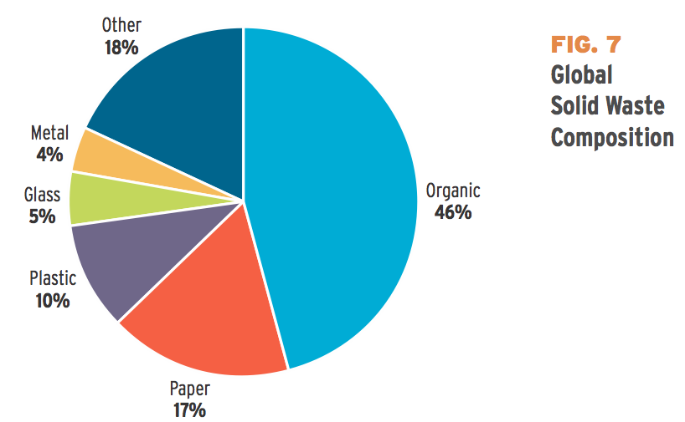

Fig 1 - A Pie Chart of Waste in America During 2012

(<http://www.theatlantic.com/business/archive/2012/06/26-trillion-pounds-of-garbage-where-does-the-worlds-trash-go/258234/>)

— There have been positive reinforcements on food waste all over the world either from commercial sources or consumer sources that reflects on some ethical issues about our current society. For example, Germany has recently issues fine for restaurants, supermarkets and residents if food items are to be found in their garbage.

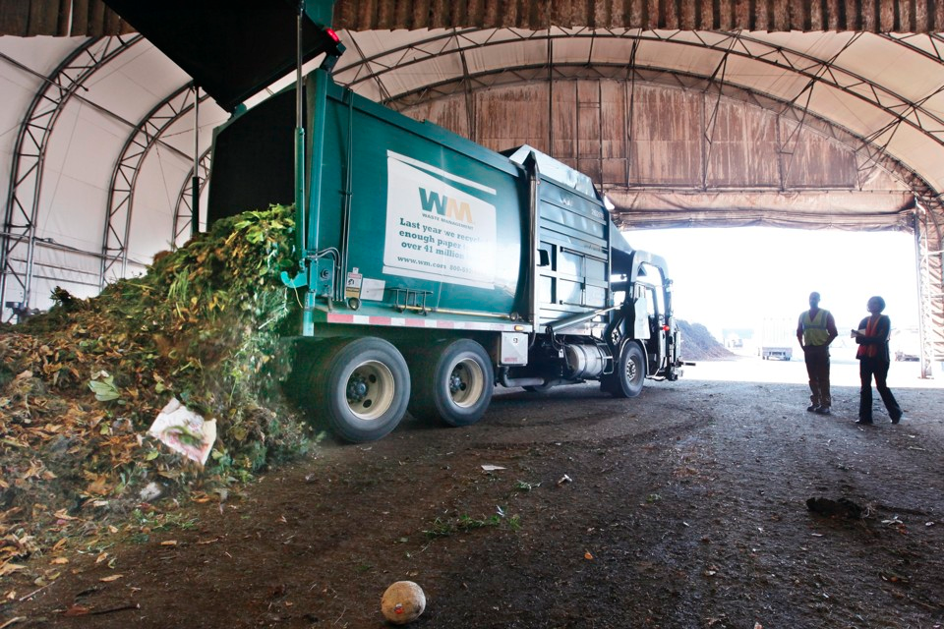

Fig 2 - Food wasted in the United States During 2016

(<http://www.theatlantic.com/business/archive/2016/07/american-food-waste/491513/>)

— And in the United States, people usually throw away 50% of their grocery within 2 week of the original purchase date simply because “out of sight, out of mind” (The Atlantic). The most throwaway food in an average household is fresh produces with a short refrigerator life span. With food issues on the rise, it is sensible to contribute to the society by helping individuals to keep track of their food usage to help eliminate waste, as well being efficient on their monthly expenses.

**Questionnaire**

— Our team created a questionnaire to collect information on whether the average user goes grocery shopping or cook. If they do not grocery shop or cook, then we ask further questions to investigate the cause of it. Consequently, we ask the users hypothetically what features they would want in a food application.

— The ultimate goal for this survey and its data is to determine the current needs in a grocery assisting app, which is a concept that is still fairly new to the consumer app market. We will interpret this data for the future design and implementation of our project.

— We will open this questionnaire until the day we begin the development process, so our group can refine the application’s requirements.

1. **Age**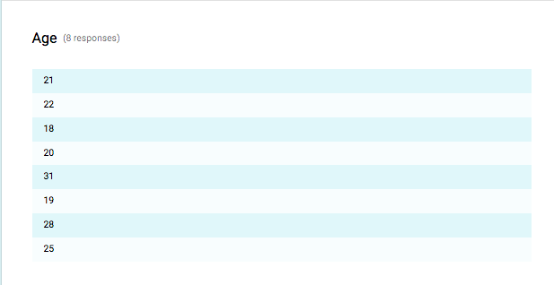
2. **Gender**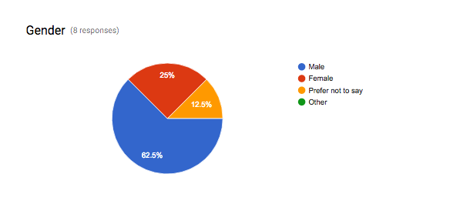
   1. Male
   2. Female
   3. Prefer not to say
   4. Other:
3. 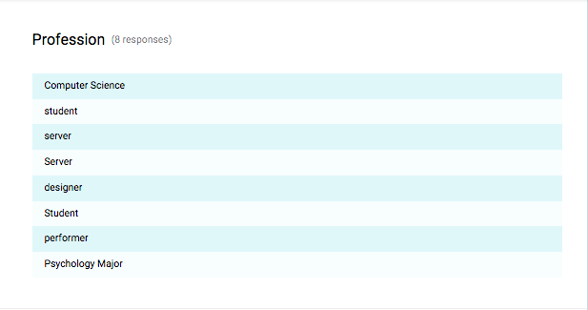**Profession**
4. **How often do you go grocery shopping?**

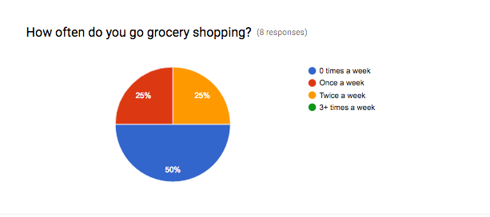

* 1. 0 times a week
  2. 1 times a week
  3. 2 times a week
  4. 3+ times a week

1. **If 0 times a week, why? If more than 0, skip this question.**

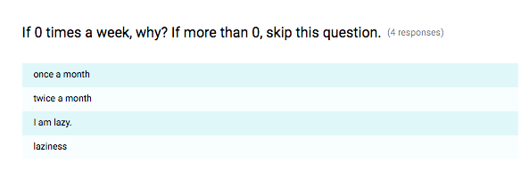

1. **Do you cook?**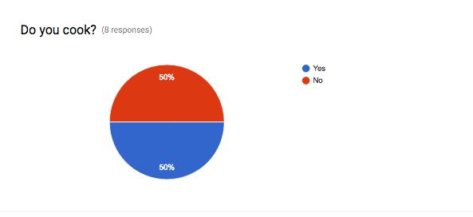
   1. Yes
   2. No
2. **If no, why? If yes, skip this question.**

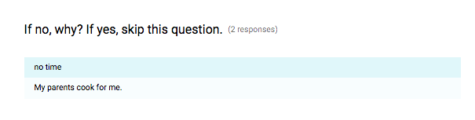

1. **What dictates what you cook?** 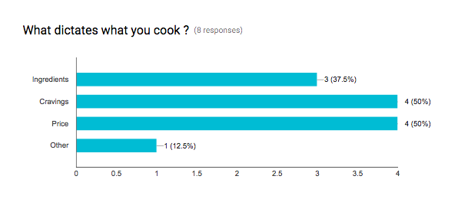
   1. Ingredients
   2. Cravings
   3. Price
   4. Other:
2. **What do you most look for in a grocery/recipe application?**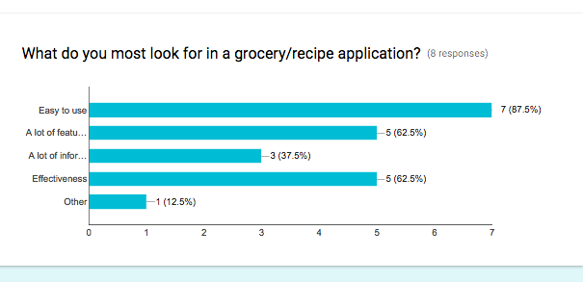
   1. Easy to use
   2. A lot of features
   3. A lot of information (Nutrition, expiration date, …)
   4. Effectiveness
   5. Other:

**API Documentation**

1. The Spoonacular API is providing the food item’s nutritional data, price, amounts and conversion, cooking tips, and health information. In addition, it will provide the recipe’s nutrition analysis, cost breakdowns, cook tips, related recipes, scaling and converting, semantic search, and ingredient to product mapping. This API will provide the data our team requires to interpret the searches the user enters into meaningful and valuable data.
   1. Spoonacular API Link — <https://spoonacular.com/food-api>
2. USDA Food Database API has detailed description and expiration day values for food lifespan which will be useful for our sorting algorithm that will base mostly on the current date and the number of day increment for food expiration. This will allow the Foodex users to be notified of their expiring food.
   1. USDA Food Database — <https://ndb.nal.usda.gov/ndb/api/doc>
3. The Free OCR API will be used as a tool to take picture of grocery receipts and convert that into letters in order to use as data for abbreviation algorithm. This will allow the Foodex user to take advantage of the camera feature to convert their receipt into food items within the application.
   1. Free OCR API link — <https://ocr.space/OCRAPI>